Ideation Phase
Brainstorm & Idea Prioritization Template

Date | 20-02-2026
Team ID | LTVIP2026TMIDS24430
Project Name | Househunt: finding your perfect rental home
Maximum Marks | 4 Marks

Brainstorm & Idea Prioritization Template:
Brainstorming provides a free and open environment that encourages everyone within a team to participate in the creative thinking process that leads to problem solving. Prioritizing volume over value, out-of-the-box ideas are welcome and built upon, and all participants are encouraged to collaborate, helping each other develop a rich amount of creative solutions.
Step-1: Team Gathering, Collaboration and Select the Problem Statement
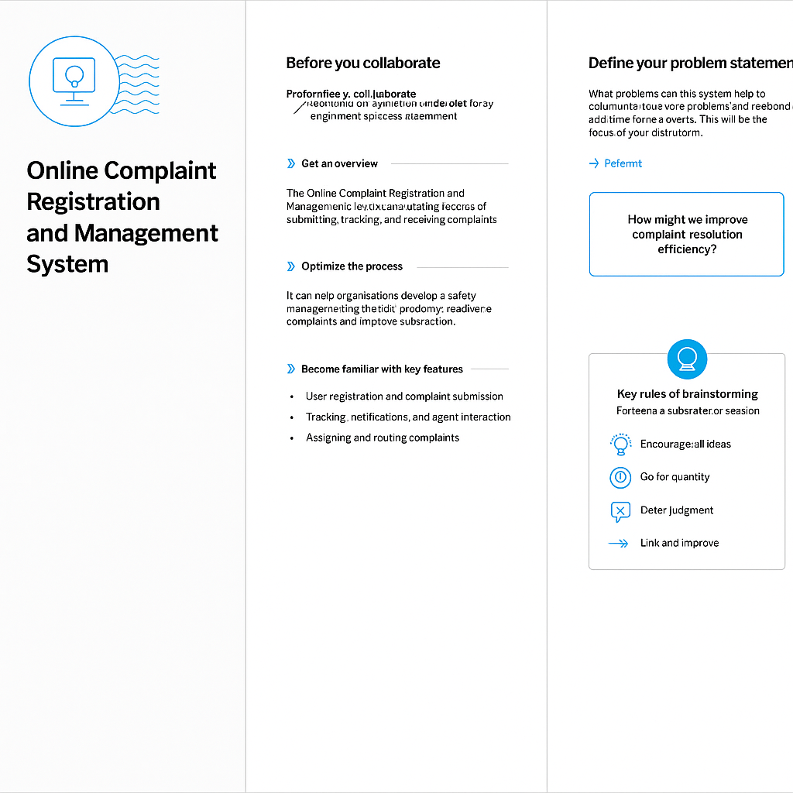

Step-2: Brainstorm, Idea Listing and Grouping


Step-3: Idea Prioritization


Ideation Phase
Define the Problem Statements

Date | 20-02- 2026
Team ID | LTVIP2026TMIDS24430
Project Name | Househunt: finding your perfect rental home
Maximum Marks | 2 Marks

Customer Problem Statement Template:
Create a problem statement to understand your customer's point of view. The Customer Problem Statement template helps you focus on what matters to create experiences people will love.
A well-articulated customer problem statement allows you and your team to find the ideal solution for the challenges your customers face. Throughout the process, you’ll also be able to empathize with your customers, which helps you better understand how they perceive your product or service.

Example:

Problem Statement (PS) | I am (Customer) | I’m trying to | But | Because | Which makes me feel
PS-1 | A traveler | Book flights on my phone | It takes a long time | The app/website is slow and not user-friendly | Frustrated
PS-2 | A traveler | Quickly compare flight options | The pages keep loading slowly | Poor app performance and heavy interface | Annoyed / Impatient

Ideation Phase
Empathize & Discover

Date | 20-02-2026
Team ID | LTVIP2026TMIDS24430
Project Name | Househunt: finding your perfect rental home
Maximum Marks | 4 Marks

Empathy Map Canvas:
An empathy map is a simple, easy-to-digest visual that captures knowledge about a user’s behaviours and attitudes.

It is a useful tool to help teams better understand their users.
Creating an effective solution requires understanding the true problem and the person who is experiencing it. The exercise of creating the map helps participants consider things from the user’s perspective along with his or her goals and challenges.
Example:
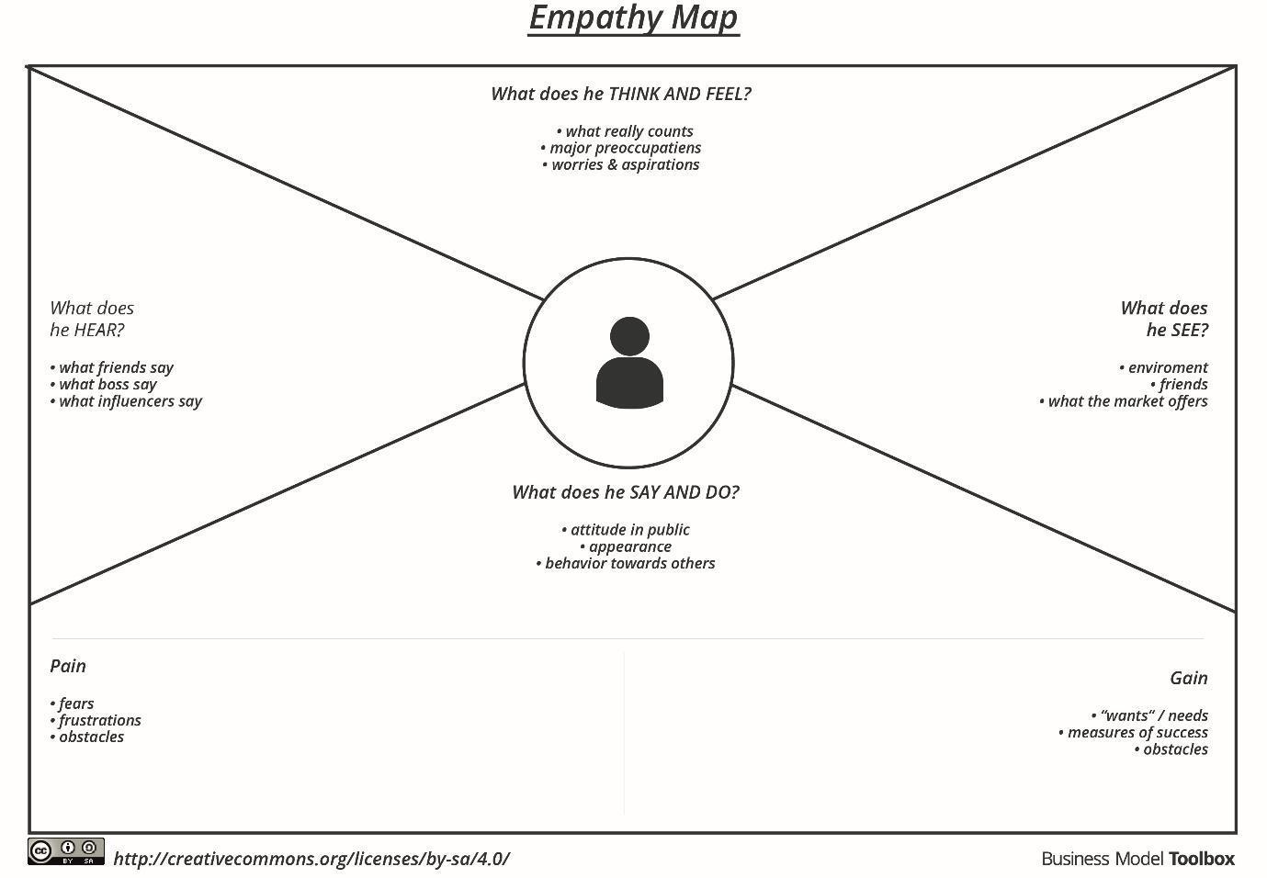

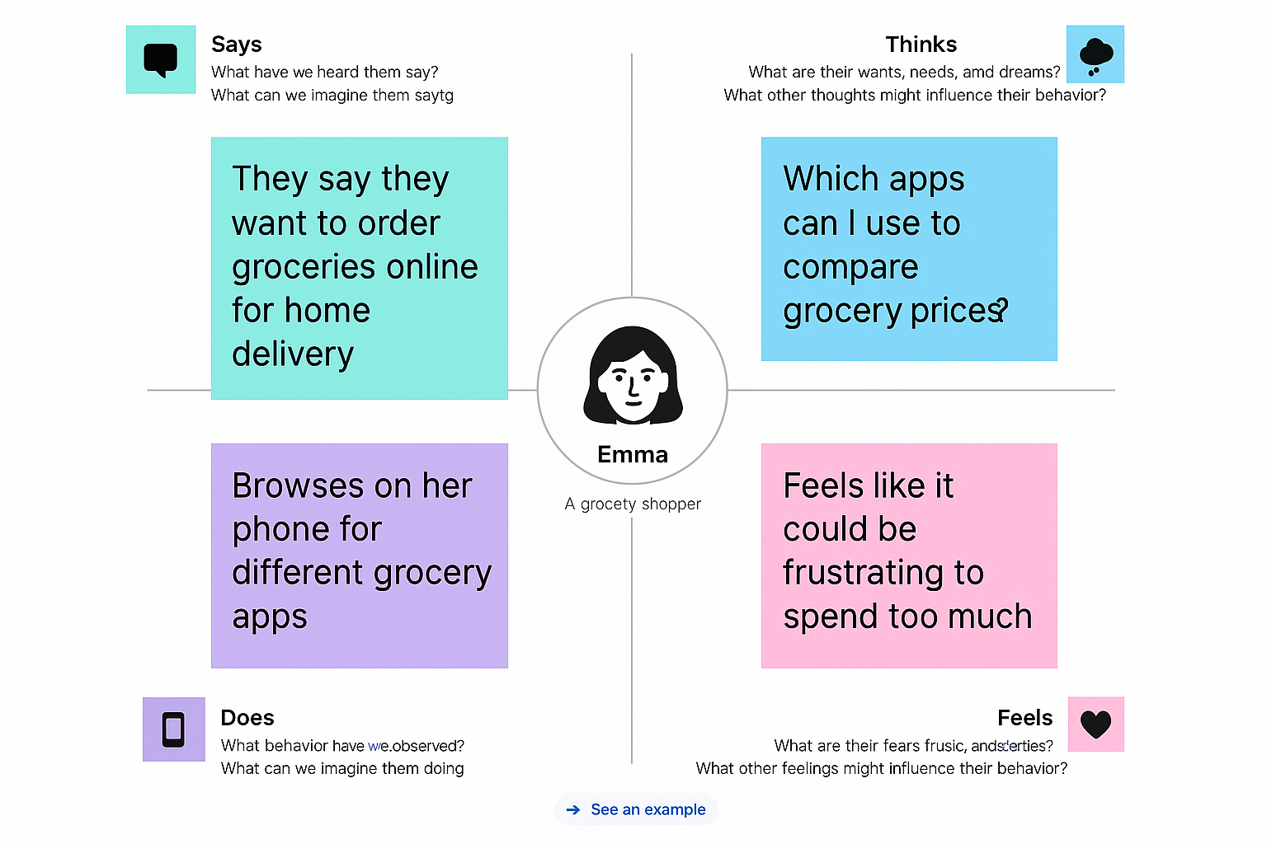
Example: Resolve Now

User Acceptance Testing (UAT) Template
Date | 20-03-2026
Team ID | LTVIP2026TMIDS24430
Project Name | Househunt: finding your perfect rental home
Maximum Marks | 2 marks

Project Overview:
Project Name: Resolve Now
Description: An online complaint registration and management system is a software application or platform that allows individuals or organizations to submit and track complaints or issues they have encountered.
Project Version:v1.0.0
Testing Period: 2025-05-26 to 2025-06-02
Testing Scope:
- User registration and login
- Complaint Submission
- Status Tracking
- Agent Communication

Requirements to be Tested:
- As a Client of ResolveNow, I want to Post the complaints easily.
- As a user, I want secure login and Post complaints.
- As an admin, I want to manage reported users and disputes.

Testing Environment:

Testing Environment
- URL: https://reslovenow.example.com

Test Cases:

Test Case ID | Test Scenario | Test Steps | Expected Result | Actual Result | Pass/Fail
TC-001 | User Registration | 1. Visit site  2. Click "Sign Up"  3. Fill & submit form | [Describe the expected outcome] | Account created, redirected to dashboard | [Pass/Fail]
...  TC-002 | ...  Post a Job (Client) | ...  1. Login as client  2. Go to "Post Job"  3. Submit form | ...Job appears on homepage | ... | ...

Bug Tracking:
Sign-off:
Tester Name: Tousif
Date: 26-05-2025
Signature:Tousif

Notes:
- Ensure that all test cases cover both positive and negative scenarios.
Bug ID | Bug Description | Steps to reproduce | Severity | Status | Additional feedback
BG-001 | Error on job posting form | 1. Login as client  2. Submit empty form | Medium | Open | Form should show validation
... | ... | ... | ... | ... | ...
- Encourage testers to provide detailed feedback, including any suggestions for improvement.
- Bug tracking should include details such as severity, status, and steps to reproduce.
- Obtain sign-off from both the project manager and product owner before proceeding with deployment.

Project Design Phase
Problem – Solution Fit Template

Date | 20-02-2026
Team ID | LTVIP2026TMIDS24430
Project Name | Househunt: finding your perfect rental home
Maximum Marks | 2 Marks

Problem – Solution Fit Overview:
The Problem–Solution Fit ensures that the ResolveNow platform effectively addresses the inefficiencies in traditional complaint handling systems and meets the real-world needs of both citizens and administrative authorities. This validation is crucial before scaling the system across departments or regions.
Purpose:
- Create a transparent, accountable channel for citizens and organizations to report complaints or issues.
- Centralize complaint management—submission, tracking, resolution—on one platform.
- Provide real-time status updates and automated notifications for better engagement.
- Empower administrators with analytics and case tracking for better governance.
- Build trust through timely responses, escalation mechanisms, and feedback collection.

Problem Statement:
Many institutions and public services face challenges like:
- Complaints getting lost or ignored due to manual systems
- No transparency or updates provided to complainants
- Delayed responses and unclear resolution timelines
- Poor tracking of repeated or high-priority issues
- Lack of data-driven insights for improving service quality

Solution:
ResolveNow, a full-stack complaint registration and management system, offers:
- Online complaint submission with unique tracking ID
- Role-based dashboards for complainants, staff, and admins
- Real-time status updates, email/SMS alerts, and escalation paths
- Complaint categorization, prioritization, and automated assignment
- Performance metrics and reports for timely resolution tracking

Project Design Phase
Proposed Solution Template

Date | 20-02-2026
Team ID | LTVIP2026TMIDS24430
Project Name | Househunt: finding your perfect rental home
Maximum Marks | 2 Marks

Proposed Solution for Resolve Now
S. No. | Parameter | Description
1 | Problem Statement (Problem to be solved) | An online complaint registration and management system is a software application or platform that allows individuals or organizations to submit and track complaints or issues they have encountered.
2 | Idea / Solution Description | The Resolve Now platform is a full-stack web application (React frontend + Node.js backend) that enables clients to post jobs, freelancers to apply, and both parties to collaborate through real-time messaging and secure payments. Admin controls help manage disputes and community standards.
3 | Novelty / Uniqueness | - Online Reporting System  -The agent will receive the reports  - Admin dispute resolution system
4 | Social Impact / Customer Satisfaction | - Impact on crime rate.  - Ease of living without fear.  - Transparent ratings & reviews enhance platform trust  - Reduces hiring friction and supports the gig economy.
5 | Business Model (Revenue Model) | - Freemium access for users.

Project Design Phase
Solution Architecture

Date | 20 -02-2026
Team ID | LTVIP2026TMIDS24430
Project Name | Househunt: finding your perfect rental home
Maximum Marks | 4 Marks

Solution Architecture:
The solution architecture for Resolve Now ensures a robust, user-friendly, and scalable platform that connects clients with skilled freelancers. The architecture focuses on responsive design, secure transactions, intelligent matching, and real-time messaging to ensure smooth project workflows and high user satisfaction.
- Seamless Crime posting on the application
- End-to-end project lifecycle managementw
- Scalable user authentication and authorization
- Secure and trackable payment transactions

Example - Solution Architecture Diagram:

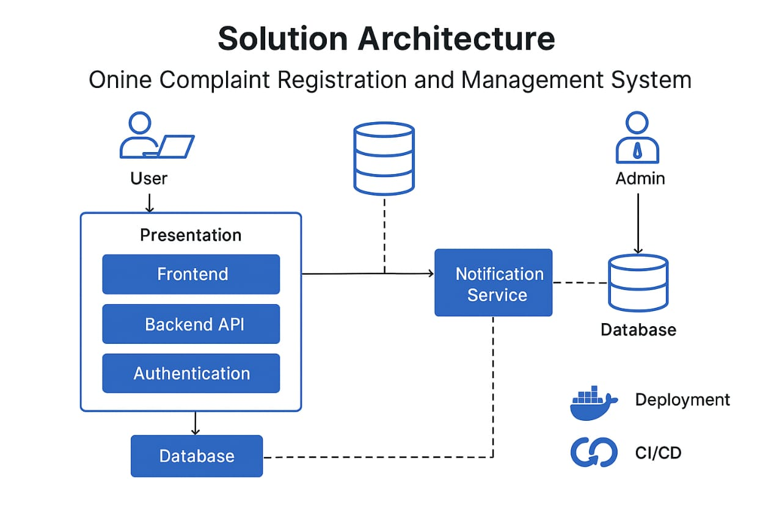

Project Planning Phase
Project Planning Template (Product Backlog, Sprint Planning, Stories, Story points)

Date | 20-02-2026
Team ID | LTVIP2026TMIDS24430
Project Name | Househunt: finding your perfect rental home
Maximum Marks | 5 Marks

Product Backlog, Sprint Schedule, and Estimation (4 Marks)

Product Backlog & Sprint Schedule
Sprint | Functional Requirement (Epic) | User Story Number | User Story / Task | Story Points | Priority | Team Members
Sprint-1 | User Authentication | USN-1 | As a user, I can sign up and log in securely. | 3 | High
 |  | USN-2 | As a user, I can reset my password. | 2 | Medium
Sprint-2 | Crime Posting | USN-3 | As a client, I can post a Complaint. | 2 | High
Sprint-3 | Application | USN-4 | As a Agent, I can take care of queries. | 3 | High
 |  | USN-5 |  | 2 | High
 |  | USN-6 | As a user, I can complaint. | 2 | Medium
Sprint-4 | Payment Integration & Reviews | USN-7 |  | 3 | High
 |  | USN-8 | As a user, I can leave a review after project completion. | 2 | Medium
 |  | USN-9 |  | 2 | Medium

Project Tracker, Velocity & Burndown Chart
Sprint | Total Story Points | Duration | Sprint Start Date | Sprint End Date (Planned) | Story Points Completed (as on Planned End Date) | Sprint Release Date (Actual)
Sprint-1 | 20 | 6 Days | 16 Dec 2025 | 22 Jan 2026 | 20 | 22 Jan 2026
Sprint-2 | 20 | 6 Days | 28 Dec  2025 | 4 Jan 2026 | 20 | 4 Jan 2026
Sprint-3 | 20 | 6 Days | 10 Jan  2026 | 16 Jan 2026 | 20 | 16 june 2026
Sprint-4 | 20 | 6 Days | 22 Jan 2026 | 28 Jan 2026 | 20 | 3 Jan 2026

Project Design Phase-II
Data Flow Diagram & User Stories

Date | 20-02-2026
Team ID | LTVIP2026TMIDS24430
Project Name | Househunt: finding your perfect rental home
Maximum Marks | 4 Marks

Data Flow Diagrams:
A Data Flow Diagram (DFD) illustrates how data moves within the Resolve Now platform. It captures how user interact with the system, how information flows between different components, and where the data is stored.
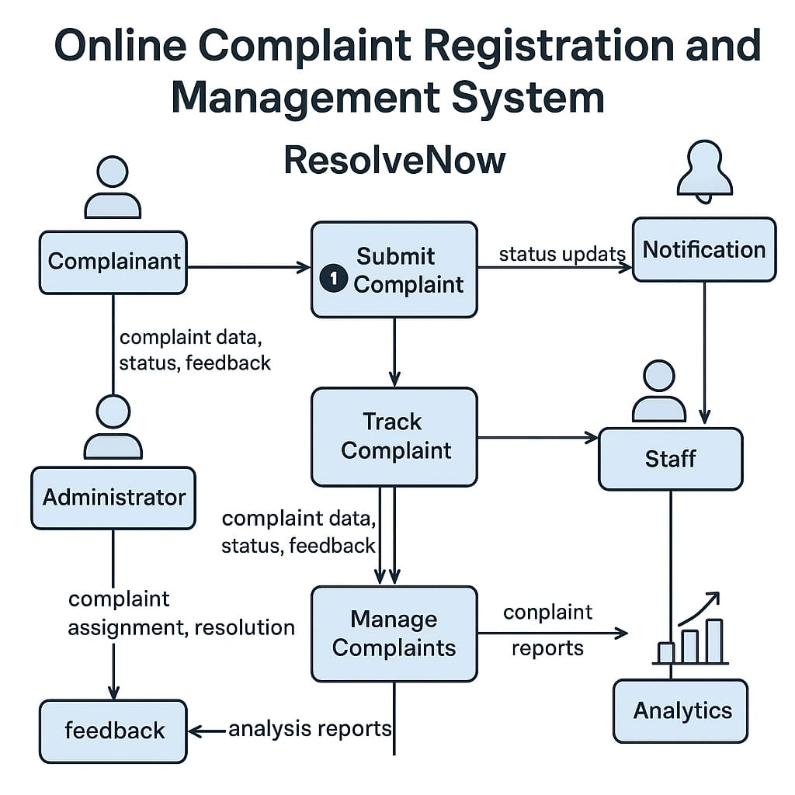

User Story Table – Freelance Finder
User Type | Functional Requirement (Epic) | User Story / Task | Acceptance Criteria | Priority | Release
Client | Query Posting | As a client, I can post a Complaint. | Query appears on home page of the agent. | High | Sprint-1
Agent | User Query | As an Agent, I will handle the queries. | Application visible to client. | High | Sprint-1
User | Messaging | As a user, I can chat with the other party in real-time. | Messages appear instantly. | Medium | Sprint-2
Client | Payment Processing | As a client, I can successfully register my complaints. | Agent will receive the queries. | High | Sprint-2
Admin | User Moderation | As an admin, I can review reported users and take action. | Reports and actions logged. | High | Sprint-1

Project Design Phase-II
Solution Requirements (Functional & Non-functional)

Date | 20-02-2026
Team ID | LTVIP2026TMIDS24430
Project Name | Househunt: finding your perfect rental home
Maximum Marks | 4 Marks

Functional Requirements:
Following are the functional requirements of the proposed solution.
Functional Requirements – Music Streaming App
FR No. | Functional Requirement (Epic) | Sub Requirement (Story / Sub-Task)
FR-1 | User Authentication | Sign up, Login, Password Reset
 |  | OAuth login using Google / GitHub
FR-2 | Crime Posting | Posting complaints
FR-3 | Job Application & Management | User will log complaints , Agent will Resolve

Non-functional Requirements:
Following are the non-functional requirements of the proposed solution.
NFR No. | Non-Functional Requirement | Description
NFR-1 | Usability | The platform should offer a clean, intuitive UI for users of all skill levels.
NFR-2 | Security | All data transfers must be encrypted. Implement role-based access and token auth.
NFR- | Performance | Pages should load within 2 seconds. Chat and job posting actions should be near-instant.
NFR- | Availability | The system should maintain 99.9% uptime across all services.
NFR- | Scalability | Should support high concurrency and rapid feature scaling through microservices.

Project Design Phase-II
Technology Stack (Architecture & Stack)

Date | 20-02-20256
Team ID | LTVIP2026TMIDS24430
Project Name | Househunt: finding your perfect rental home
Maximum Marks | 4 Marks

Technical Architecture:
The Resolve Now platform is designed with a scalable 3-tier architecture that includes the presentation layer (frontend), business logic (backend), and data storage layer. The solution ensures performance, security, and ease of integration with third-party APIs (e.g., Stripe for payments).

Table-1 : Components & Technologies:
S.No | Component | Description | Technology
 | User Interface | Web-based interface for clients and freelancers | HTML, CSS, JavaScript / React Js etc.
 | Application Logic-1 | Complaints posting | Node.js, Express.js
 | Application Logic-2 | Admin panel | React js, Node js
 | Database | Stores user data, jobs, applications, messages | MongoDB

Table-2: Application Characteristics:
S.No | Characteristics | Description | Technology
 | Open-Source Frameworks | Frontend frameworks | React.js, Node.js, BootStrap, Tailwind CSS
 | Scalable Architecture | 3-tier architecture with RESTful APIs | Microservices

